ER Mesh Generation Tutorial: Buried Metallic Box, Sheet, and Line

Overview
In this example, we demonstrate how to build a mesh with infinite conductivity inclusions. The jupyter notebook mbsl_ERT1.ipynb takes the user through the steps in this tutorial. The file clear_files.ipynb resets the directory to contain files before running mbsl_ERT1.ipynb. The directory named visit contains the xdmf files created using px, and electrode locations for visualization.

Conceptual Diagram
In this example, we build a mesh comprising surface electrodes, three buried infinite conductivity structures (a box, a sheet, and a line), a foreground zone defined for convenient visualization, and a boundary zone that extends from the foreground zone to the external boundaries. A conceptual diagram of the subsurface is shown in Figure 1 The mesh consists of three lines of surface electrodes, where line 1 includes control points 1 through 16, line 2 includes control points 17 through 32, and line 3 includes control points 33 through 48. Control points 49 through 52 and 57 through 60 define the foreground region, which is assigned zone 1. Control points 61 through 68 define the conductive box. Control points 69,70,73 and 74 through 76 define the conductive sheet, and points 125-148 define the conductive line. The region extending from the foreground to the outer boundaries is not shown, but is assigned zone 2. The mesh configuration file for Figure 1 (mbsl.cfg) is shown below, with annotations denoting the corresponding mesh configuration file variables.
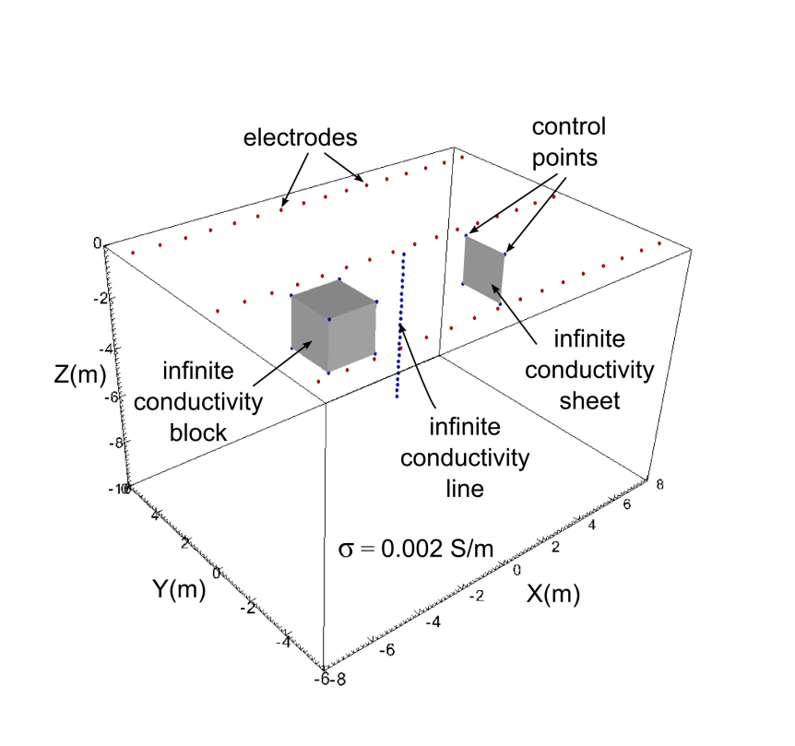
Figure 1. Conceptual diagram of surface electrodes with a subsurface containing an infinite conductivity box, sheet, and line embedded in a background medium with a conductivity of 0.002 S/m. Each of the control points and electrode points shown are listed in the mesh configuration file mbsl.cfg.

Building the mbsl Mesh
In addition to the mesh configuration file, the run configuration file e4d.inp is needed to build the mesh. In mode ERT1, the only file that must be listed is the mesh configuration file. The run configuration file for this example is shown below.
<begin run configuration file e4d.inp> (this line is not included in the file)
ERT1
mbsl.cfg
<end run configuration file e4d.inp> (this line is not included in the file)
To build the mesh, execute the command:
<e4d_dir>/bin/mpirun -np 1 <e4d_dir>/bin/e4d
or
mpirun -np 1 e4d
if <e4d_dir>/bin is in the executable path, where <e4d_dir> is the E4D installation directory. E4D builds the input files for triangle and tetgen, and calls each to build the mesh. E4D then builds a conductivity file for the mesh as specified in the mesh configuration file, and calls bx to build an exodus file for visualization. The files generated include:
File | Generated by | Description
mbsl.poly | e4d | Tetgen input file generated by E4D. Not used in run modes > 1.
mbsl.1.node | tetgen | Tetgen node file. Gives the nodal coords of the mesh.
mbsl.1.ele | tetgen | Tetgen element file. Describes how nodes are connected to form elements.
mbsl.1.face | tetgen | Tetgen face file. Describes which nodes form boundary faces.
mbsl.1.neigh | tetgen | Tetgen neighbor file. Provides neighbors of all elements.
mbsl.sig | e4d | Conductivity file. Describes element conductivities and is written to the exodus file.
mbsl.xmf / mbsl.h5 | px | Xdmf files used to visualize mesh and conductivity distribution.
mbsl.exo | bx | Exodus file used to visualize mesh and conductivity distribution.

mbsl Mesh Visualization
Figure 2 shows a visualization of the mesh produced using VisIt with the xdmf file mbsl.xmf.
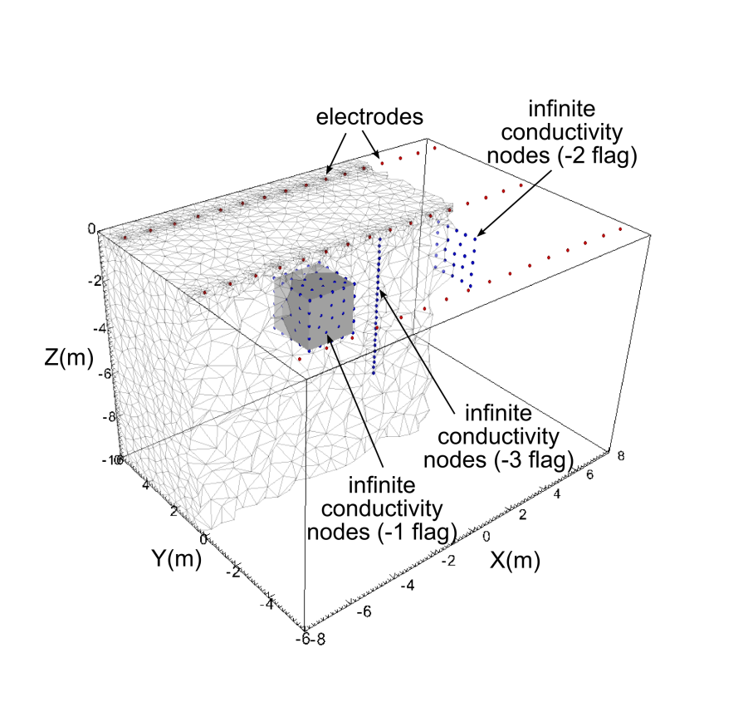
Figure 2. Cut-out view of the mbsl mesh showing nodes added by tetgen for the three infinite conductivity boundaries. Note that the grey region representing the infinite conductivity box is shown only for reference. The mesh is hollow in the interior of the box; only the outer boundary of the box is included in the mesh.

Mesh Configuration File: mbsl.cfg

<begin mesh configuration file mbsl.cfg> this line is not included in two_blocks.cfg

1.3 1e12 mesh quality (m_qual), max volume (max_evol_def)
-500 bottom of mesh elevation (m_bot)
1 flag to build mesh (tet_build_flag)
"tetgen" command to run tetgen (tet_loc)
"triangle" command to run triangle (tri_loc)
148 number of control points (n_cpts)
1 -7.5 -5 0 1 1 x1 y1 z1 b_flag_1
2 -6.5 -5 0 1 2 x2 y2 z2 b_flag_2
3 -5.5 -5 0 1 .
4 -4.5 -5 0 1 .
5 -3.5 -5 0 1 .
6 -2.5 -5 0 1
7 -1.5 -5 0 1
8 -0.5 -5 0 1
9 0.5 -5 0 1
10 1.5 -5 0 1
11 2.5 -5 0 1
12 3.5 -5 0 1
13 4.5 -5 0 1
14 5.5 -5 0 1
15 6.5 -5 0 1
16 7.5 -5 0 1
17 -7.5 0 0 1
18 -6.5 0 0 1
19 -5.5 0 0 1
20 -4.5 0 0 1
21 -3.5 0 0 1
22 -2.5 0 0 1
23 -1.5 0 0 1
24 -0.5 0 0 1
25 0.5 0 0 1
26 1.5 0 0 1
27 2.5 0 0 1
28 3.5 0 0 1
29 4.5 0 0 1
30 5.5 0 0 1
31 6.5 0 0 1
32 7.5 0 0 1
33 -7.5 5 0 1
34 -6.5 5 0 1
35 -5.5 5 0 1
36 -4.5 5 0 1
37 -3.5 5 0 1
38 -2.5 5 0 1
39 -1.5 5 0 1
40 -0.5 5 0 1
41 0.5 5 0 1
42 1.5 5 0 1
43 2.5 5 0 1
44 3.5 5 0 1
45 4.5 5 0 1
46 5.5 5 0 1
47 6.5 5 0 1
48 7.5 5 0 1
49 -8 -6 0 1 upper control points for foreground (zone 1)
50 -8 6 0 1
51 8 6 0 1
52 8 -6 0 1
53 -500 -500 0 2 boundary control points
54 -500 500 0 2
55 500 500 0 2
56 500 -500 0 2
57 -8 -6 -10 0 lower control points for forground (zone 1)
58 -8 6 -10 0
59 8 6 -10 0
60 8 -6 -10 0
61 -4.0 -1.0 -1.0 -1 Upper control points conductive block
62 -4.0 1.0 -1.0 -1
63 -2.0 1.0 -1.0 -1
64 -2.0 -1.0 -1.0 -1
65 -4.0 -1.0 -3.0 -1 lower control points conductive block
66 -4.0 1.0 -3.0 -1
67 -2.0 1.0 -3.0 -1
68 -2.0 -1.0 -3.0 -1
69 4.0 -1.0 -1.0 -2 control points 69-70 define the upper edge of the metal sheet
70 4.0 1.0 -1.0 -2
71 2.0 1.0 -1.0 0
72 2.0 -1.0 -1.0 0
73 4.0 -1.0 -3.0 -2 control points 73-74 define the lower edge of the metal sheet
74 4.0 1.0 -3.0 -2
75 2.0 1.0 -3.0 0
76 2.0 -1.0 -3.0 0
77 -7.5 -5 -0.05 0 additional points for electrode refinement
78 -6.5 -5 -0.05 0
79 -5.5 -5 -0.05 0
80 -4.5 -5 -0.05 0
81 -3.5 -5 -0.05 0
82 -2.5 -5 -0.05 0
83 -1.5 -5 -0.05 0
84 -0.5 -5 -0.05 0
85 0.5 -5 -0.05 0
86 1.5 -5 -0.05 0
87 2.5 -5 -0.05 0
88 3.5 -5 -0.05 0
89 4.5 -5 -0.05 0
90 5.5 -5 -0.05 0
91 6.5 -5 -0.05 0
92 7.5 -5 -0.05 0
93 -7.5 0 -0.05 0
94 -6.5 0 -0.05 0
95 -5.5 0 -0.05 0
96 -4.5 0 -0.05 0
97 -3.5 0 -0.05 0
98 -2.5 0 -0.05 0
99 -1.5 0 -0.05 0
100 -0.5 0 -0.05 0
101 0.5 0 -0.05 0
102 1.5 0 -0.05 0
103 2.5 0 -0.05 0
104 3.5 0 -0.05 0
105 4.5 0 -0.05 0
106 5.5 0 -0.05 0
107 6.5 0 -0.05 0
108 7.5 0 -0.05 0
109 -7.5 5 -0.05 0
110 -6.5 5 -0.05 0
111 -5.5 5 -0.05 0
112 -4.5 5 -0.05 0
113 -3.5 5 -0.05 0
114 -2.5 5 -0.05 0
115 -1.5 5 -0.05 0
116 -0.5 5 -0.05 0
117 0.5 5 -0.05 0
118 1.5 5 -0.05 0
119 2.5 5 -0.05 0
120 3.5 5 -0.05 0
121 4.5 5 -0.05 0
122 5.5 5 -0.05 0
123 6.5 5 -0.05 0
124 7.5 5 -0.05 0
125 0 0 -0.25 -3 points 125 - 126 define a metallic line (e.g. well casing)
126 0 0 -0.5 -3
127 0 0 -0.75 -3
128 0 0 -1 -3
129 0 0 -1.25 -3
130 0 0 -1.5 -3
131 0 0 -1.75 -3
132 0 0 -2 -3
133 0 0 -2.25 -3
134 0 0 -2.5 -3
135 0 0 -2.75 -3
136 0 0 -3 -3
137 0 0 -3.25 -3
138 0 0 -3.5 -3
139 0 0 -3.75 -3
140 0 0 -4 -3
141 0 0 -4.25 -3
142 0 0 -4.5 -3
143 0 0 -4.75 -3
144 0 0 -5 -3
145 0 0 -5.25 -3
146 0 0 -5.5 -3
147 0 0 -5.75 -3
148 0 0 -6 -3
12 number of internal planes (n_plc)
4 10 number of points in plc 1 (np1), boundary number(b_num_1)
49 50 58 57 control points in plc 1: western boundary of zone 1
4 10 np2 b_num_2
50 51 59 58 control points in plc 2: northern boundary of zone 1
4 10 .
51 52 60 59 eastern boundary of zone 1
4 10 .
52 49 57 60 southern boundary of zone 1
4 10 .
57 58 59 60 bottom boundary of zone 1
4 -1
61 62 66 65 western boundary of metal box
4 -1
62 63 67 66 northern boundary of metal box
4 -1
63 64 68 67 eastern boundary of metal box
4 -1
64 61 65 68 southern boundary of metal box
4 -1
61 62 63 64 upper boundary of metal box
4 -1
65 66 67 68 lower boundary of metal box
4 -2
69 70 74 73 metal sheet

1 number of holes ... 1 for the metal box
2 -2.5 0.0 -2.5 point inside the metal box

2 number of zones ... 2
1 0.0 0.0 -5.0 0.1 0.002 1 xz_1 yz_1 zz_1 mz_vol_1 cond_1
2 0.0 0.0 -20.0 1e12 0.002
1 flag to build visualization file (bex_flag)
'px' command to build xdmf file (bex_loc)

<end mesh configuration file mbsl.cfg> this line is not included in mbsl.cfg

